SOFTWARE TESTING REPORT
TUTORIAL–12: AI-Powered Software Testing

Particulars | Details
Student Name | Parth Fegade
Enrollment Number | 2504030100083
Programme | BCA — Semester 3
Testing Tools | Python, Selenium WebDriver, PyCharm, Google Chrome, Generative AI
Application Under Test | SauceDemo — saucedemo.com
Date | 29 October 2026

1. Aim
To apply Generative AI techniques to login requirement analysis and test-case preparation, then execute a Selenium WebDriver test in Python to verify that valid SauceDemo credentials navigate to the inventory/products page.

2. Objectives
- Analyze the login requirement and identify positive and negative scenarios.
- Prepare sample test cases, test data, and expected results.
- Identify possible defect-prone areas in the login module.
- Review Selenium Python code before executing it in PyCharm.
- Verify successful login using the destination URL and console output.

3. Tools and Technologies
Tool | Purpose
Python | Programming language used for the automated test.
Generative AI | Assists with requirement analysis, test cases, test data, and code drafting.
Selenium WebDriver | Automates browser interaction and checks the login result.
PyCharm | IDE used to review and run the Python script.
Google Chrome | Browser used to execute the test.
SauceDemo | Demo e-commerce website used as the application under test.
WebDriverWait / Expected Conditions | Waits for page elements or URL conditions before continuing.

4. Test Case Details
Field | Details
Test Case ID | TC-12-01
Scenario | Login using valid credentials
Preconditions | Python and Selenium are configured, Chrome is available, and SauceDemo is accessible.
Test Data | Username: standard_user; Password: secret_sauce
Expected Result | Login succeeds and the browser navigates to the inventory/products page.
Observed Result | Supplied PyCharm console screenshot shows “AI-Assisted Selenium Test: PASS” and “Requirement Validation: PASS”.
Status | PASS — based on supplied execution evidence

Additional AI-generated scenarios from Tutorial–12:
Test Case ID | Scenario | Test Data | Expected Result
TC-12-02 | Invalid Password | standard_user / wrong123 | Login rejected; error displayed.
TC-12-03 | Invalid Username | wrong_user / secret_sauce | Login rejected; error displayed.
TC-12-04 | Empty Username | Blank / secret_sauce | Username validation message displayed.
TC-12-05 | Empty Password | standard_user / Blank | Password validation message displayed.

5. Test Procedure
- Open PyCharm and open the Python project.
- Import Selenium WebDriver, By, WebDriverWait, and expected conditions.
- Launch Chrome and maximize the browser window.
- Open https://www.saucedemo.com/ and wait for the username and password fields.
- Enter standard_user in the username field and secret_sauce in the password field.
- Click the Login button.
- Wait until the current URL contains “inventory”.
- Assert that “inventory” is present in the current URL and print the PASS messages.
- Close the browser using driver.quit() in a finally block.

6. Result and Analysis
The supplied PyCharm screenshots show the Selenium script completing successfully. The console displays “AI-Assisted Selenium Test: PASS”, “Requirement Validation: PASS”, and “Process finished with exit code 0”. This evidence supports the successful-login result for the valid-credentials scenario. The screenshots do not independently demonstrate execution of every negative test case listed above.
Execution Item | Observed Result | Status
Open SauceDemo | Login page opened for testing | Pass
Enter valid credentials | Script entered the sample username and password | Pass
Submit login form | Login button clicked | Pass
Verify destination | Inventory URL condition and assertion passed | Pass
Script completion | Process finished with exit code 0 | Pass

7. Screenshot Collage
The four supplied screenshots are included as visual evidence. They show the test-data examples, the SauceDemo test-case table, the Selenium script in PyCharm, and the passing console output.
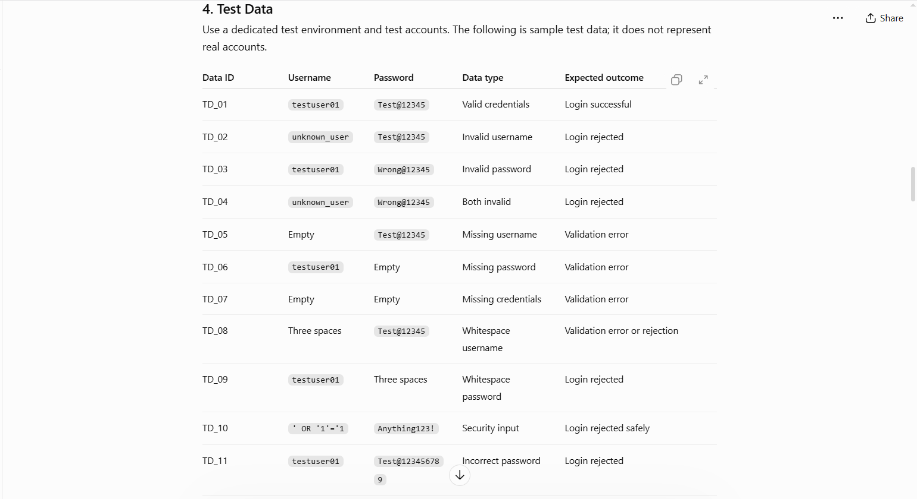 | 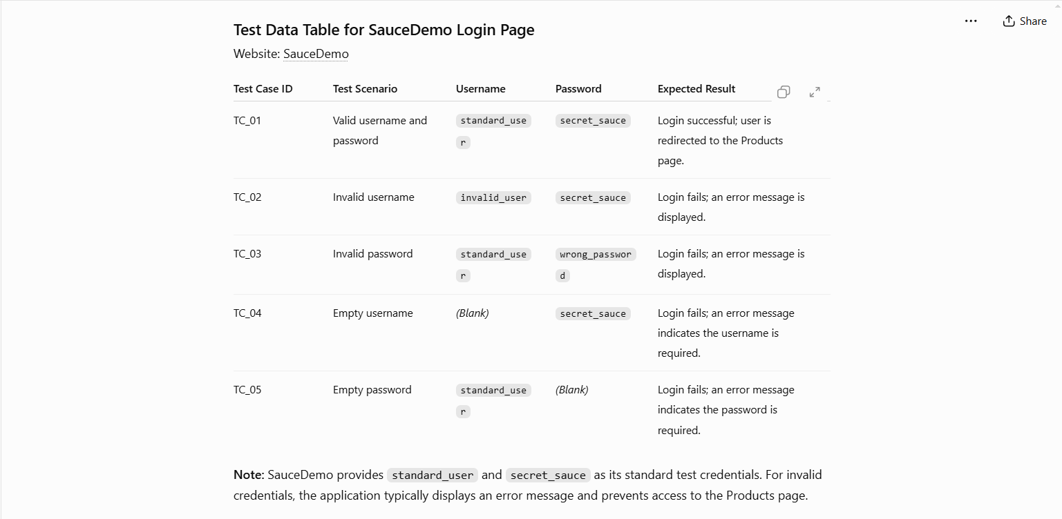
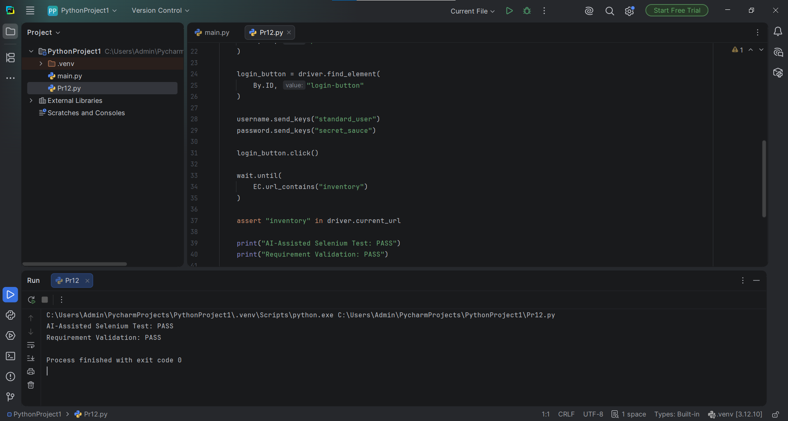 | 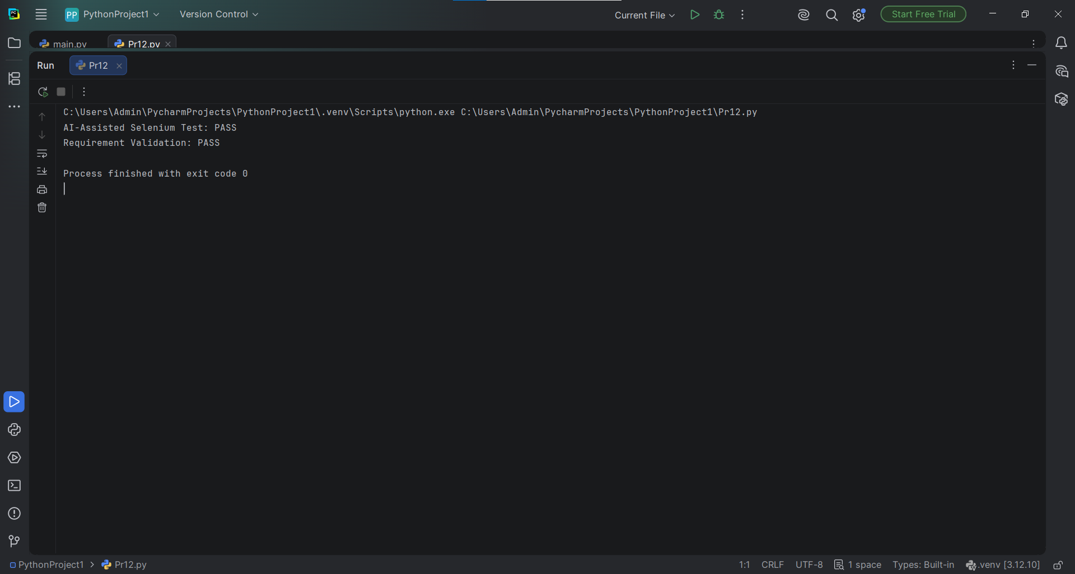

8. Individual Screenshot Evidence
Screenshot 1 — Sample login test data and expected outcomes.
Screenshot 2 — SauceDemo login test-case table.

Screenshot 3 — PyCharm Selenium script and passing console output.
Screenshot 4 — Console output showing PASS results and exit code 0.

9. Conclusion
Tutorial–12 demonstrated how Generative AI can support requirement analysis, test-case generation, test-data preparation, defect-prone area identification, and Selenium code drafting. The supplied execution evidence indicates that the valid SauceDemo credentials were accepted, navigation to the inventory page was verified, and the automation completed successfully. AI-generated outputs should be reviewed before execution, and negative scenarios should be run separately to confirm full coverage.

